



ADVANCED OFFICE SYSTEMS & PROCEDURES
(225)

STATE 2021

Objective (10 @ 5 points each) __________ (50 points)

Production:
Job 1: Memorandum __________ (100 points)

Job 2: Letter __________ (100 points)

Job 3: Spreadsheet __________ (100 points)

Job 4: Letter with Merge Codes Merged __________ (100 points)

Job 5: Merged Letter __________ (50 points)

TOTAL POINTS __________ (500 points)

Test Time: 90 minutes

GENERAL GUIDELINES:

Failure to adhere to any of the following rules will result in disqualification:
- Member must hand in this test booklet and all printouts if any. Failure to do so will result in disqualification.
- No equipment, supplies, or materials other than those specified for this event are allowed in the testing area. No previous BPA tests and/or sample tests (handwritten, photocopied, or keyed) are allowed in the testing area.
- Electronic devices will be monitored according to ACT standards.

EXAM GUIDELINES:

- Ensure this test booklet contains Jobs 1-5.
- Key all jobs according to the instructions given.
- Correct any and all formatting, spelling or grammar errors. Use the formatting guide in the Style & Reference Manual.
- Your name or initials should not appear on any work you submit. Use your contestant number in any occasion you would normally key your reference initials.
- In the lower right hand corner of ALL work submitted (unless otherwise specified) key your Member ID and job number.
- If you complete the event before the end of the time allotted, notify the proctor. Time could be considered a factor in determining a winner when there is a tie score.
- Place your scoring sheet on top of your Jobs. Jobs should be placed in numerical order.

PRODUCTION STANDARDS
0 Errors | 100 Points
1 Error | 90 Points
2 Errors | 70 Points
3 Errors | 50 Points
4+ Errors | 0 Points

Multiple Choice: Identify the letter that best completes each sentence or answer the question and mark it on the Scantron form provided.

- C
- B
- D
- B
- D
- C
- D
- D
- A
- D

Job 1: Memorandum
MEMORANDUM (16 point font)

TO: Pat Hutson, Hannah Dundore, Maria Scott, Kay Rudolph, Jamie Knight, Luca Pense

FROM: Julie Smith (may also include title)

DATE: Current Date

SUBJECT: Human Resource Manual

It is that time of year again where we need to update the Human Resource Manual for Digital Solutions. The last time that we updated it was September 2019. You are each being tasked with a section to review and update. It is important that you not only look over section but share with each other to proofread each other’s. Below is a table that will tell you which section each of you are to oversee updating and the corresponding pages.

Section | Person | Page Numbers
Employment | Pat Hutson | 9-15
Workplace Policies | Hannah Dundore | 16-17
Social Media Policy | Maria Scott | 18-19
Work Schedule | Kay Rudolph | 19-20
Performance and Compensation Reviews | Jamie Knight | 20-24
Safety and Security | Luca Pense | 24-26

Attached is a copy of the current Human Resource Manual. This must be completed by Monday, March 22, 2021. Let me know if you have any questions or concerns.

xx (Member ID)

Attachment

Grader Notes:
- Margins – 1" all the way around
- Production Standards
- 0 errors = 100 points; 1 error = 90 points; 2 errors = 70 points, 3 errors = 50 points, 4 or more errors = 0 points
Member ID
Job#
Current Date
Job 2: Letter

Ms. Jennifer Edwin
10987 Cedar Valley Ridge
Columbus, OH 45504

Dear Ms. Edwin

UPDATED HUMAN RESOURCE MANUAL

The Human Resource Department has worked to update the current file. They have done a wonderful job with getting it current with what is going on in today’s workforce. With that being said, it is important that we get final approval from the Board of Directors for the current manual. I have attached the most recent revision from the HR Department.

One thing that the team is suggesting is that we include a letter of reassignment or transfer. With the continued growth of Digital Solutions, they feel it is important that this be part of the current manual. Since the company prefers to promote from within.

I would like to thank Julie Smith, Pat Hutson, Hannah Dundore, Maria Scott, Kay Rudolph, Jamie Knight, and Luca Pense for their dedication to this project. It was a major undertaking on their part. If you have any questions, feel free to contact Julie Smith (Julie.Smith@digitalsolutions.com) or myself (Nancy.Wells@digitralsolutions).

Sincerely

Nancy Wells
Chief Executive Officer

xx (Contestant ID)

Enclosure

c Julie Smith

Grader Notes:
- Margins – Top Margin 2”; Left, Right, and Bottom Margins 1"
- Production Standards
- 0 errors = 100 points; 1 error = 90 points; 2 errors = 70 points, 3 errors = 50 points, 4 or more errors = 0 points
Member ID
Job#
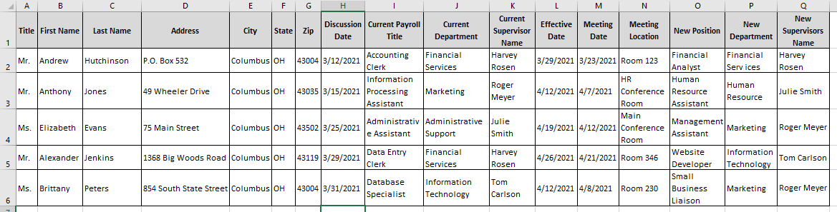
Job 3: Spreadsheet

Grader Notes:
- Production Standards
0 errors = 100 points; 1 error = 90 points; 2 errors = 70 points, 3 errors = 50 points, 4 or more errors = 0 points
- This document can be done in any of the following programs (it is up to the student which one):
  - Spreadsheet
  - Word
  - Database

Member ID
Job#

Job 4: Letter with Merge Codes

Current Date

«AddressBlock»

Dear «First_Name»

As per our discussion on «Discussion__Date», your position as a «Current_Payroll_Title», in «Current_Department» Department has been reassigned effective «Effective_Date». Your current position and salary will not change.

A meeting has been scheduled on «Meeting_Date» at 3:00 p.m. in «Meeting_Location» with «New_Supervisors_Name» to discuss your duties, discuss performance expectations, and work schedule.

Please contact «New_Supervisors_Name» if you have any questions about the position. I wish you success in your new department.

Sincerely

Julie Smith, Manager
Human Resource Department

c Nancy Wells

Grader Notes:
- Margins – Top Margin 2”; Left, Right, and Bottom Margins 1"
- Merge Codes should be printed for this document.
- Production Standards
- 0 errors = 100 points; 1 error = 90 points; 2 errors = 70 points, 3 errors = 50 points, 4 or more errors = 0 points

Member ID
Job#
Job 5: Merge Letter

Current Date

Mr. Andrew Hutchinson
P.O. Box 532
Columbus, OH 43004

Dear Andrew

As per our discussion on 3/12/2021, your position as a Accounting Clerk, in Financial Services Department has been reassigned effective 3/29/2021. Your current position and salary will not change.

A meeting has been scheduled on 3/23/2021 at 3:00 p.m. in Room 123 with Harvey Rosen to discuss your duties, discuss performance expectations, and work schedule.

Please contact Harvey Rosen if you have any questions about the position. I wish you success in your new department.

Sincerely

Julie Smith, Manager
Human Resource Department

c Nancy Wells

Grader Notes:
- Printed letter with filled information
  - 5 points for each field
  - 50 points total

Member ID
Job#

